PADE Beyond Fundamentals Series – January and February 2022
Homework for Workshop 2 – January 15 and 19 (repeat), 2022

Note: this should take no longer than 10 minutes!

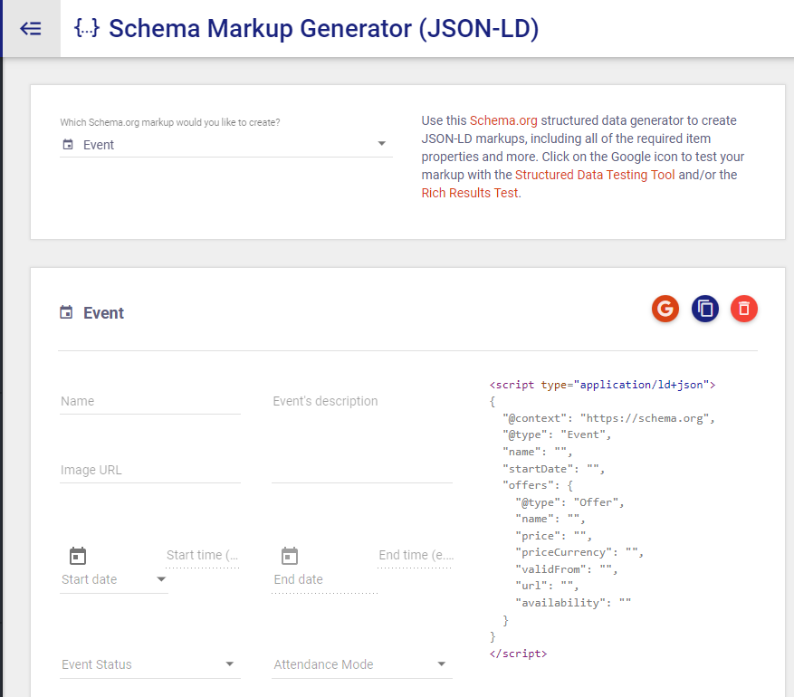
Schema Markup

- Go to this Schema Mark Up Generator https://technicalseo.com/tools/schema-markup-generator/
- Select which type of schema.org markup you want to create, I suggest “event”
- Fill in the information and copy the resulting schema text into Word.
- Test the schema using the Structured Data Testing Tool by clicking on the Google icon
- Send it to ipetri@strategicmoves.ca for review prior to the workshop.

